**Index Code Validation**



Here is an error that I wasn’t sure how to fix as I wasn’t sure what was wrong with the code



Here is another issue which I wasn’t sure how to fix as there wasn’t anything wrong with my code



Simple error which required me to change the p1 tag to p

**Portfolio Code Validation**

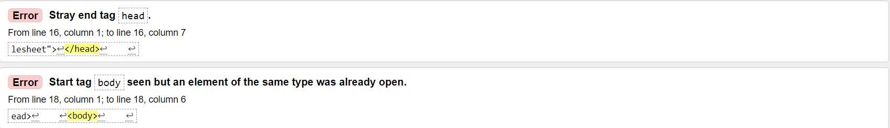

I had 2 more of these validation errors which I didn’t know how to fix, the head tag was in the correct place and there was only one <body> tag



Simple fix, it didn’t require </br> at the end

**CV Code Validation**



Needed to change the <p> within h3 to be <h3> as well, however, when this was changed it had broke the responsiveness of the web page which I couldn’t figure out how to fix

**Contact Code Validation**



Not sure why the footer tag was stray, couldn’t fix this issue.

There wasn’t much to validate within the HTML, which could be due to validation I done during Assignment 1.

**CSS Validation**



To fix the issue, I aligned the links to the center and not to the left



To fix this issue, I noticed I added an extra auto, so I deleted one and it was fixed.

**JavaScript validation**

When validating my JavaScript I used this site <https://esprima.org/demo/validate.html>, which showed I had no errors within my code, shown in the screenshot below.

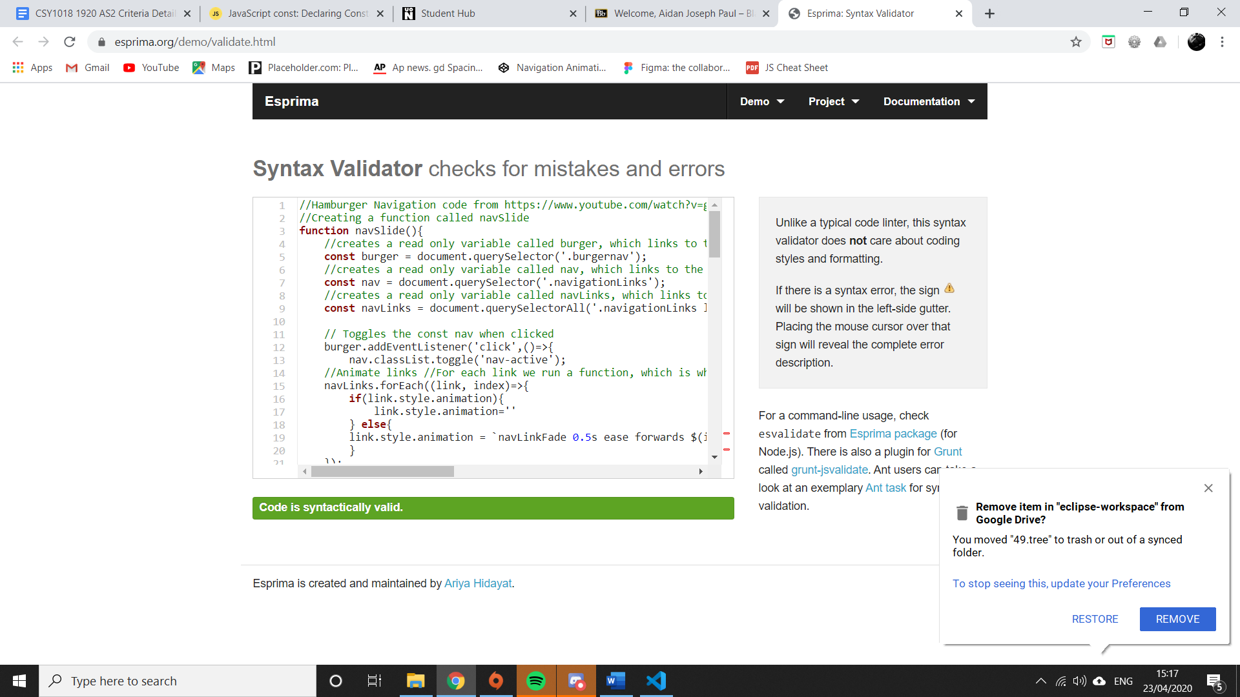

**Github heat map**

Shown below is my github heat map. The heat map looks like it doesn’t have much on, however it hasn’t counted some of my commits due to I believe doing things on separate computers, however you can see with my assignment repo itself it has 28 commits alone, this doesn’t count for the class challenges and anything extra that I have done

